TEACHERS’ PROGRAMME ON PREVENTION OF EARLY SCHOOL LEAVING
MAYO EDUCATION CENTRE
Module 4 – EDUCATIONAL EVALUATION

MODULE 4 – EDUCATIONAL EVALUATION AGENDA

Welcome and Introductions
- Introduction of tutors and participants
- Any thoughts on early school leaving since last session
Introduction to Module 4 - Educational Evaluation
- Aims of the module
Exploration of the project portal
- Exploration of the project portal
  - Check into the ‘Meeting Space’
  - Respond to posted comments
Module 4 – Communication
- Exploration of module on portal or read through on hard copies
- Discussion on the module
Module 4 – Comments on the module on the forum
  - Each teacher has the opportunity to post comments on to the School Inclusion Forum
Evaluation of the workshop

PRESENT were:

Ms Marie Verity
Ms Rosaleen Sullivan
Mr Daniel Forde
Mr Denis O’Boyle
Ms Josephine McDonagh
Ms Sarah Sheridan
Ms Philomena Browne
Aine Ni
Chonghamhna
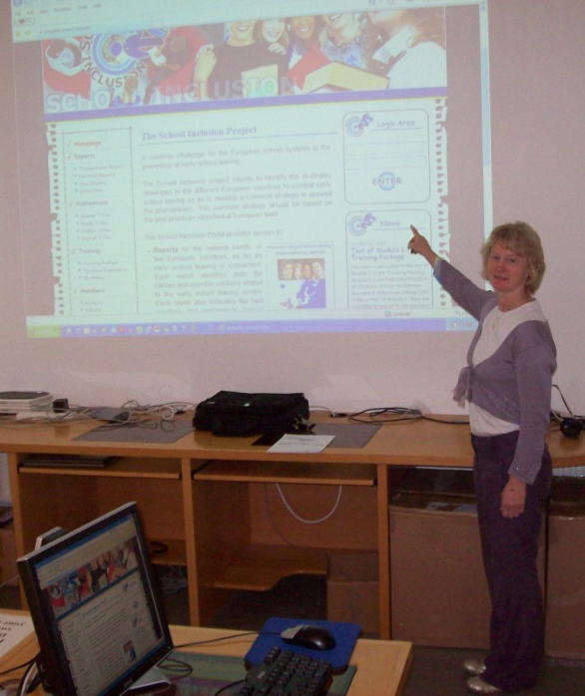
Participants focussed on the content and information available in Module 4 of the Training Package.
The session went well. Participants were now familiar with each other and so the session began easily and quickly. Participants were also now familiar with the School Inclusion Portal. They had ease in accessing the Portal, exploring the data and enjoyed utilising the Meeting Space.
It was valuable and interesting to witness responses and comments in the Meeting Space and to acknowledge similar experiences and solutions to early school leaving in schools and institutions.
The ‘Educational Evaluation’ module was undertaken. Hard copies of the module were available for those who preferred to explore it in this way – rather than on the web. Participants entered into the task of evaluating the module and were keen to learn and apply the learning to their teaching situation.
Responses
STRENGTHS
Comprehensive information on evaluation methods, styles and possibilities
Comprehensive examination of all eventualities regarding evaluation
Excellent background information
Well researched

WEAKNESSES
Practical application of the information with examples and situations
Examples in relation to early school leaving might have been useful to the readers and educationalists present
The training module is has excellent material and presented with academic tome and language. Simpler language may make it more user friendly
Use of actual examples for teacher/school addressing the issue of early school leaving might be useful

OPPORTUNITIES
Encourages teachers to explore new methods of evaluation
Offers teachers new ways of applying hte informationa dn techniques already in use.
The use of diagrams, photos – some visual application may make it more usable

THREATS
Its academic nature may be a threat to frequent use of the module

In conclusion Module 4 was considered an excellent module with great potential for teachers and educators to evaluate programmes and responses to early school leaving.

